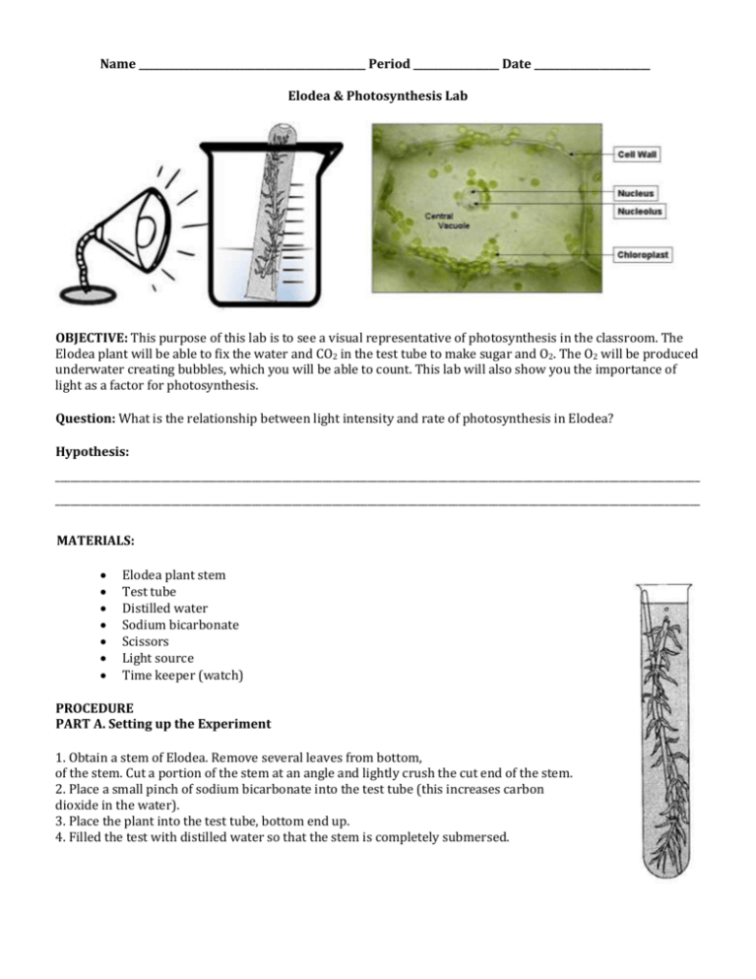
Procedures continued
Part B.

5. Place the Lamp 30 cm from the plant setup for 5 minutes.
6. Count the bubbles coming from the Elodea and record in the table.
7. Place the Lamp 20 cm from the plant setup for 5 minutes.
8. Count the bubbles coming from the Elodea and record in the table.
9. Place the Lamp 10 cm from the plant setup for 5 minutes.
10.Count the bubbles coming from the Elodea and record in the table.
Lamp Distance from Elodea | Number of Oxygen Bubbles

Questions:
- What role does the Sodium Bicarbonate play in the Lab?

- Look up and record the Chemical Formula for Sodium Bicarbonate.

- Was your Hypothesis agreed or disagreed?

- What did you like about this Lab?

